This document describes a low-level test case for the performance of the cse in terms of accuracy and efficiency.

**Error** is a measurement of accuracy defined as the absolute deviation between the analytical solution and the simulation. In simulation, the factors that influence the error are: model, solver, micro-step size, and, naturally, the size of the time interval to be simulated. In this context of co-simulation, the error analysis focus on the added error introduced by the coupling of the subsystems in the co-simulation framework.

**Real Time Factor (RTF)** is a measurement of efficiency defined as the division of the simulation time and the real time. RTF larger than 1 is considered as capable of real-time simulation.

**Test case:**

A quarter truck model is used as illustrated below.

mc

mw

z

kc

kw

dc

dw

Three FMUs are generated namely chassis, wheel and ground. The ground and chassis each have one bond for connection, the wheel has two bonds that are commutative to those of the ground and chassis.

The FMUs have the following input and output variables for connection:

|  |  |  |  |
| --- | --- | --- | --- |
| FMU | bond | | |
| ground | p | | |
| plug | socket | |
| p.f | p.e | |
| FMU | bond | | |
| wheel | p | | |
| socket | | plug |
| p.f | | p.e |

|  |  |  |
| --- | --- | --- |
| FMU | bond | |
| wheel | p1 | |
| plug | socket |
| p1.f | p1.e |
| FMU | bond | |
| chassis | p | |
| socket | plug |
| p.f | p.e |

*Naming conventions of the variables is to be decide. Preferable the variable names are concise but also descriptive in case that multiple connectors exist and give some indication for connection.

The FMUs have the following output state variables:

|  |  |
| --- | --- |
| FMU | plug |
| ground | zGround |
| FMU | plug |
| wheel | zWheel |
| FMU | plug |
| chassis | zChassis |

The following parameters are used:

|  |  |
| --- | --- |
| Wheel mass | mWheel = 40kg |
| Chassis mass | mChassis = 400kg |
| Wheel spring | kWheel = 150000Nm-1 |
| Wheel damper | dWheel = 0Nsm-1 |
| Chassis spring | kChassis = 15000Nm-1 |
| Chassis damper | dChassis = 1000Nsm-1 |

The ground profile is defined as a step function. Starting from equilibrium state, the ground profile is excited by the jump 0.1m in z-direction at 1s. Figure 1 shows the displacements of the masses.

**Reference solution:** RK4 – 1000HZ

|  |  |  |  |
| --- | --- | --- | --- |
| **Integration Method** | **Time step** | **RTF** | **Error** |
| 20sim RK4 | 0.001 | ~200 | - |
| 20sim-Cosim RK4 | 0.01 | ~100 |  |
| CSE-client | 0.01 | ~100-200 |  |



Figure 1. Displacements of the quarter truck 0.001s (solid line), reimplementation in 20sim co-simulation 0.01s macro-step (cross line)

Figure 2.Displacements of the quarter truck model in cse co-simulation 0.01s macro-step

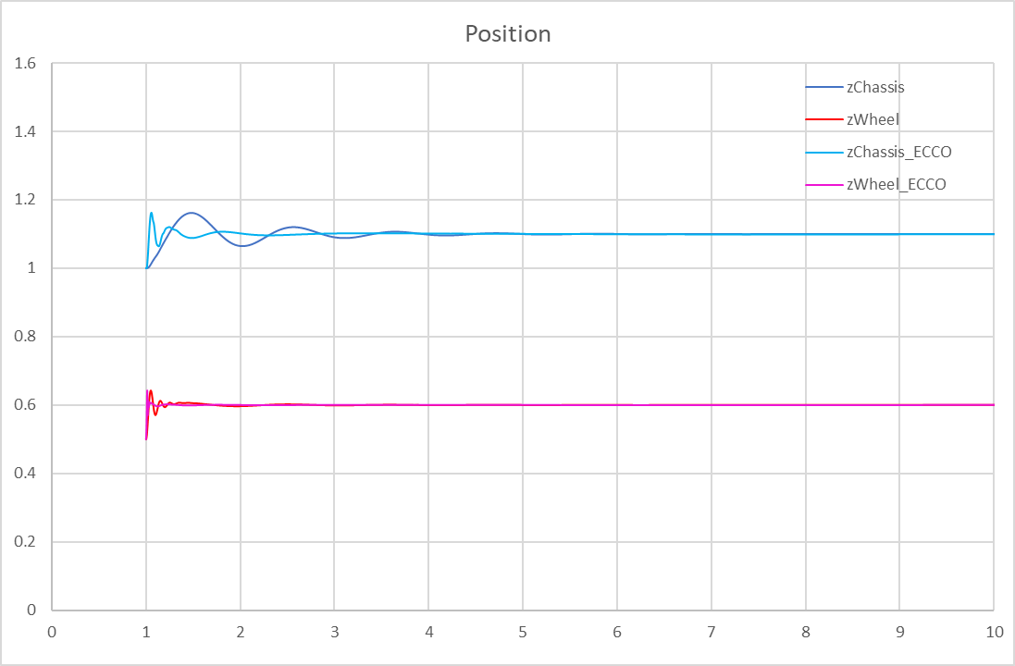

Figure 3. Displacements of the quarter truck model in Mathematica 0.001s

**Quantified error estimation:**

In order to enforce reliable macro-step control algorithms, error estimation is needed. Classic Richardson extrapolation and a modified error estimator is described in [1].

**Requirements of FMI library functions (in FMI 2.0) for variable macro-steps algorithms:**

fmiGetFMUState

fmiSetFMUState

fmiSetRealInputDerivatives

fmiGetRealOutputDerivatives

**Reference**

1. Arnold, M., Clauss, C., & Schierz, T. (2014). Error analysis and error estimates for co-simulation in FMI for model exchange and co-simulation V2. 0. In Progress in Differential-Algebraic Equations (pp. 107-125). Springer, Berlin, Heidelberg.